# Government art and science college

# srivilliputhur

# anallysing housing prices in metropolitan areas of india

# 1.Introduction:

In the sprawling landscape of urban India, metropolitan areas stand as economic and cultural epicenters, drawing millions of residents and businesses seeking opportunity and growth. In these bustling cities, housing is not just a necessity but a reflection of socio-economic dynamics, investment potential, and the quality of life. The analysis presented herein embarks on a journey through the complex tapestry of housing prices in India's metropolitan regions.

The metropolitan areas of India, including but not limited to Mumbai, Delhi, Bangalore, Kolkata, and Chennai, are home to diverse populations, each with distinct housing needs and aspirations. As urbanization accelerates, the quest for affordable yet desirable housing options becomes an ever more pressing concern.

# 1.1.Overview:

1. **Metropolitan Dynamics**: India's metropolitan areas serve as hubs of economic and cultural activity, attracting a diverse and ever-growing population. Understanding the housing market within these regions is essential to comprehend the broader socio-economic landscape.
2. **Data-Driven Approach**: This research employs a data-driven approach to analyze housing prices, using a combination of historical data, market trends, and other relevant information. The quantitative analysis aims to provide a comprehensive and evidence-based view of the housing market.
3. **Diverse Housing Needs**: The housing needs and aspirations of residents in these metropolitan areas vary significantly, influenced by factors like income, lifestyle, and family dynamics. This analysis aims to capture these diversities and their impact on housing prices.
4. **Factors Affecting Housing Prices**: It explores the myriad factors that drive housing prices, including demand and supply dynamics, location, infrastructure, policy interventions, and economic conditions. By dissecting these variables, the research aims to reveal their individual and collective influence.
5. **Regional Disparities**: Metropolitan areas in India differ considerably in terms of housing affordability and market trends. The research assesses regional disparities, allowing for a more nuanced understanding of the housing landscape.
6. **Impact on Stakeholders**: Beyond the monetary aspects, the analysis considers the broader implications of housing prices on residents, investors, and the real estate sector as a whole. This insight informs decision-making for various stakeholders.

# 1.2.Purpose:

1. **Understanding Market Dynamics**: This analysis seeks to gain a comprehensive understanding of the housing market in India's metropolitan areas. By examining price trends and market dynamics, it aims to uncover the factors driving housing costs.
2. **Quantifying Affordability**: One of the central objectives is to assess the affordability of housing in these regions. The research aims to determine whether housing is within reach for various segments of the population, considering factors such as income levels and family structures.
3. **Regional Disparities**: The research intends to highlight regional disparities in housing prices. By comparing different metropolitan areas, it can identify areas where housing costs are particularly high or low, providing insights into the variations across regions.
4. **Economic and Social Implications**: Analyzing housing prices has broader implications for economic development and social well-being. This research aims to understand how housing affordability or the lack thereof affects the quality of life and economic opportunities for residents.
5. **Policy Formulation**: By shedding light on the factors influencing housing prices, the analysis can provide valuable insights for policymakers. It offers evidence-based data to craft policies aimed at addressing housing challenges and fostering sustainable urban development.
6. **Investment Decisions**: The research serves as a resource for real estate investors and developers, offering insights into market trends and areas with potential for growth. This information can guide investment decisions in the real estate sector.

# 2.Problem statement & design thinking:

Housing affordability and the dynamics of housing prices in the metropolitan areas of India represent a complex and multifaceted challenge. While these regions offer economic opportunities and cultural diversity, they also face rising disparities in housing costs, posing a significant problem for residents, policymakers, and real estate stakeholders. The problem statement for this analysis is to investigate the factors driving housing prices, the impact of regional disparities, and the implications for housing affordability in India's metropolitan areas.

This problem statement encapsulates the overarching issues the analysis aims to address, including the driving forces behind housing price variations, the consequences of these disparities on residents, and the need for informed policy solutions.

# 2.1.Empathy map:Untitled_2023-09-04_07-11-30.jpg

# 2.2.Ideation and brainstorming map:

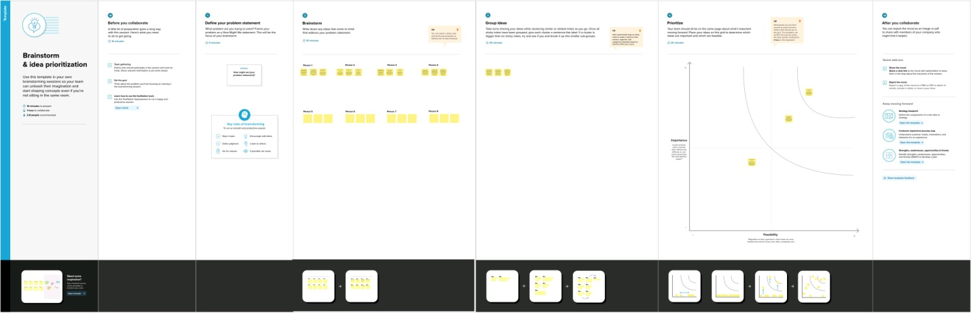

# 3.result:sheet2.pngsheet3.pngsheet4.pngsheet5.pngsheet6.pngsheet7.pngsheet8.pngdashboard1.png

# 4.advantages:

1. **Informed Decision-Making**: The analysis provides valuable data that can help individuals, real estate developers, and investors make informed decisions about buying, renting, or developing properties in these high-demand regions.
2. **Policy Formulation**: Policymakers can use the insights to formulate and implement housing policies that address affordability issues and promote sustainable urban development.
3. **Market Insights**: Real estate professionals can gain insights into market trends, helping them adapt their strategies to changing demand and supply dynamics.
4. **Economic Growth**: A better understanding of housing dynamics can contribute to economic growth by ensuring that housing remains affordable for a wide range of income groups, thereby promoting workforce stability.
5. **Social Equity**: Identifying regional disparities in housing prices can guide efforts to reduce inequality and improve social equity by addressing housing affordability issues in disadvantaged areas.

# disadvantages:

1. **Complexity**: The housing market is inherently complex, and while analysis can provide insights, it may not fully capture all the factors influencing housing prices.
2. **Data Limitations**: The availability and accuracy of data on housing prices can vary, making it challenging to conduct a comprehensive analysis, particularly in regions where data may be incomplete or unreliable.
3. **Privacy Concerns**: Collecting and analyzing data on housing prices may raise privacy concerns for property owners, especially if individual data is disclosed or misused.
4. **Rapid Market Changes**: Housing markets can be highly dynamic, and trends may change rapidly, making it challenging to keep analyses up-to-date.
5. **Local Variations**: The analysis may not fully capture the intricacies of localized variations within metropolitan areas, which can significantly affect housing prices.
6. **Risk of Gentrification**: Efforts to address housing affordability could unintentionally lead to gentrification, where lower-income residents are displaced by higher-income individuals.

# 5.application:

1. **Real Estate Investment and Development**:
   * Real estate developers and investors can use the analysis to identify lucrative opportunities and make informed decisions regarding property development and investment strategies in metropolitan areas.
2. **Government and Policy Development**:
   * Policymakers can utilize the findings to develop housing policies and urban planning strategies that address affordability, housing shortages, and regional disparities in metropolitan areas.
3. **Financial Institutions**:
   * Banks and financial institutions can apply the insights to assess the risk associated with mortgage lending and formulate lending policies and interest rates based on market conditions.
4. **Homebuyers and Renters**:
   * Prospective homebuyers and renters can benefit from the analysis to make informed decisions about where to live and whether to buy or rent, taking into consideration housing prices and affordability.
5. **Urban Planning and Infrastructure**:
   * City planners and infrastructure development authorities can use the research to plan public transportation, utilities, and other amenities based on housing dynamics and population distribution.
6. **Real Estate Professionals**:
   * Real estate agents, brokers, and consultants can use the data to provide better guidance to their clients regarding market trends and potential investments.

# 6.conclusion:

In conclusion, the application of analyzing housing prices in metropolitan areas of India is multifaceted and holds immense potential for improving the housing landscape, economic development, and social well-being in these urban centers. The insights gained from such analysis can contribute to informed decision-making and effective policy development.

By understanding the driving forces behind housing prices, regional disparities, and their implications, stakeholders across various sectors can benefit significantly. Real estate developers and investors can identify opportunities, governments can formulate better policies, and financial institutions can refine lending practices. Prospective homebuyers, renters, and real estate professionals can make more informed choices, while urban planners can design better infrastructure.

# 7.future scope:

1. **Predictive Models**: Developing predictive models to anticipate housing price trends, considering economic, demographic, and policy factors. This can assist stakeholders in making proactive decisions.
2. **Affordable Housing Initiatives**: Expanding the application to include detailed studies on affordable housing initiatives, their impact, and areas where such initiatives are most needed.
3. **Sustainability and Green Housing**: Analyzing the influence of sustainability and green building practices on housing prices and assessing the future prospects of eco-friendly housing in metropolitan areas.
4. **Real-Time Data**: Utilizing real-time data and advanced analytics to offer up-to-the-minute insights into housing market trends, enabling timely decision-making for investors and buyers.
5. **Housing Market Risk Assessment**: Developing tools for assessing housing market risks, which can be beneficial for financial institutions and investors.
6. **Impact of Remote Work**: Exploring how the rise of remote work and telecommuting in a post-pandemic world influences housing preferences and price dynamics.
7. **Inclusion of Non-Metropolitan Areas**: Expanding the analysis to include non-metropolitan areas to provide a holistic view of housing dynamics across urban and rural regions.